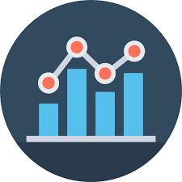

HR Analytics Report

For Altera

July 16

Benson Nyota

**PREAPRED BY:**

**TABLE OF CONTENTS**

* Introduction
* Data Preparation
* Dashboard Design and Features
* Key Insights
* Recommendations
* Conclusion

**INTRODUCTION**

**Project Objective:**

In the rapidly evolving business landscape, organizations are increasingly recognizing the importance of data-driven decision-making to enhance their competitive edge. Human Resources (HR) departments, in particular, are leveraging analytics to gain deeper insights into their workforce and drive strategic initiatives. This report outlines the development of an HR analytics dashboard designed to provide insightful reporting on the workforce of our organization.

The primary objective of this report is to serve as a robust decision support tool, enabling HR professional to monitor and analyze key metrics and performance indicators effectively.

**Scope:**

The analysis encompasses nearly every aspect of organizational concerns. This includes the total number of employees, gender distribution across the company, age distribution of employees, and gender distribution by departments and regions. Additionally, it highlights awards won by the company employees, broken down by gender and departments, and showcases various key performance metrics.

**Data Preparation**

**Data Source:**

Data used is from Altera company. It contains necessary information regarding the employees that works and have worked there.

**Data Cleaning:**

* Checked for missing values and due to their minority aspect the data was dropped.
* Ensured data accuracy including outliers

**Data Preparation:**

* Developed essential measures, such as total population and gender-based population counts.
* Measures created to show gender subtotals for different work schedules, including full-time and part-time employees.

**Dashboard Design and Features**

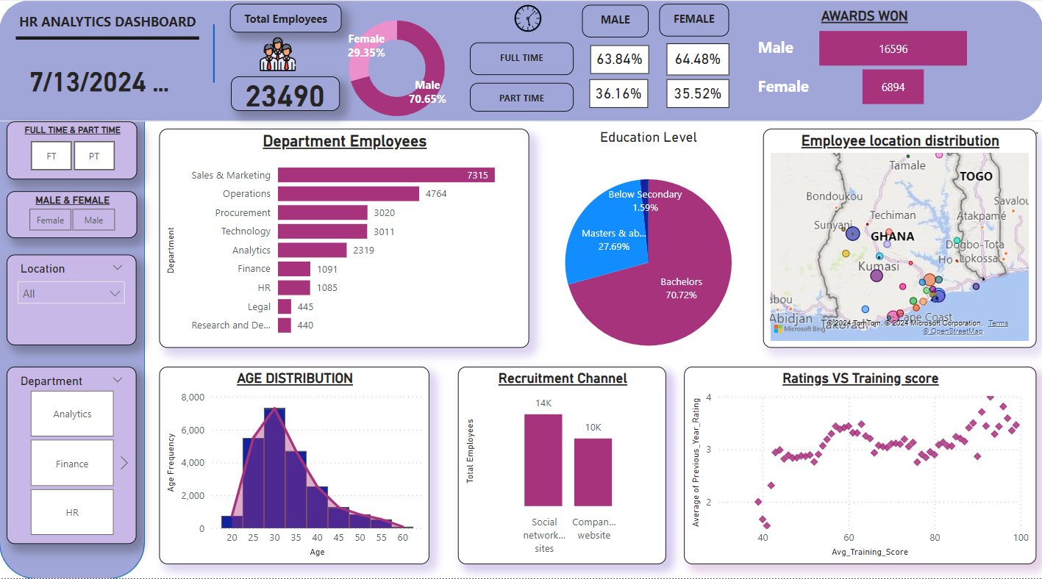

**Workforce Composition:**

* The company has a total of 23,490 employees, with a male-dominated workforce exceeding 70%.
* Full-time employment is the norm, with over 63% in both genders.
* Sales and Marketing boast the highest number of employees compared to other departments.

**Educational Background:**

* Employees with a Bachelor's degree form the largest group, followed by those with Master's degrees.
* Less than 2% of the workforce has only a secondary education or lower.

**Location:**

* While a small number commute from far locations like, a majority of employees reside near the coast.

**Age Distribution:**

* The middle-aged population makes up the largest demographic within the company.

**Recruitment Channels:**

* Social network emerges as the primary source for attracting new talent, with successful recruitment through these channels.

**Training and Performance:**

* A positive correlation exists between higher average training scores and better performance ratings.

**Key Insights**

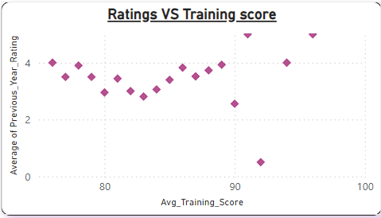

Research & Development employees received good ratings, suggesting that their skills and experience may be more critical to success than formal training in this department.

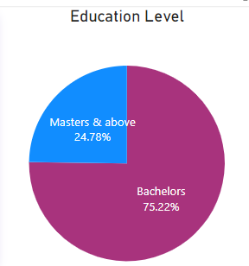

Departments like Sales and Marketing, Research and Development and Analytics require a high level of expertise. This is reflected in the fact that the minimum educational qualification for these critical departments is a Bachelor's degree.

In Research & Development Department Males dominated in the Award wining

**Implications:**

A skills gap is emerging in critical departments like **Finance** and **Technology**, where there appears to be a rise in the percentage of employees with educational qualifications below a secondary school.

This could potentially impact departmental efficiency.

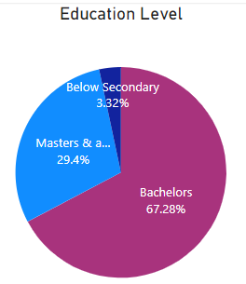

**Recommendations:**

**Strategy:**

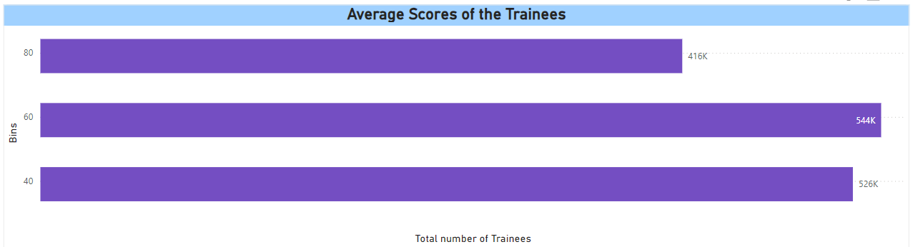 Refining the trainee selection criteria can help ensure a better fit between trainees and training programs, potentially reducing instances of low performance.

**Improvements:**

To gain a more comprehensive understanding of the company's financial health and overall direction, consider including additional data such as dated revenue generation.

**Conclusions:**

**Summary:**

On this analysis we have revealed a workforce of 23,490 with male being the majority and a prevalence of full-time from employees. Sales and Marketing lead in departmental population size, while a Bachelor's degree is the most common educational background in the company.

Social network plays a big role in recruitment focus and a link between training scores and performance which mean most of the trainees should perform better.

However, a potential skills gap in critical departments like Finance and Technology warrants keen observation.